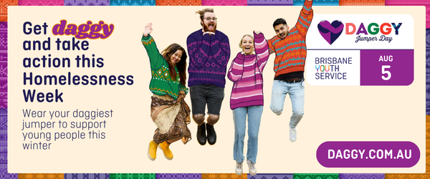

SOCIAL MEDIA SUGGESTED CAPTIONS (simply copy and paste)
Pre-Daggy Jumper Day social caption #1: Announce your support | [Our students / Our team / Our community] are getting daggy this Homelessness Week to show that hope is always in style Will you join us? Every action helps support young people experiencing or at risk of homelessness this winter.  Visit daggy.com.au to get on board and find easy ways you can take part.  [or]  If you’d like to be part of the impact, you can donate to our Daggy fundraiser: [insert your Daggy fundraising page link]  #DaggyJumperDay #HomelessnessActionNow #BrisbaneYouthService
Pre-Daggy Jumper Day social caption #2: Impact-led | When a young person has a safe place to call home, everything else becomes more possible.  This Homelessness Week, we’re teaming up with Brisbane Youth Service and getting daggy to support young people across Brisbane.  Visit daggy.com.au to join the daggy community and see easy ways you can get involved.  [or]  If you’d like to help make a bigger impact this winter, you can donate to our fundraiser: [insert your Daggy fundraising page link]  #HopeIsAlwaysInStyle #HomelessnessActionNow #DaggyJumperDay
Pre-Daggy Jumper Day social caption #3: Community-led | Daggy jumpers on, community spirit strong  Schools, workplaces, and communities across Brisbane are getting behind Brisbane Youth Service’s #DaggyJumperDay to take action this Homelessness Week – and we’re proud to be part of it.  Visit daggy.com.au to join the daggy community and access ready-to-use resources.  [or]  If you’d like to be part of what we’re making possible, please donate to our fundraiser: [insert your Daggy fundraising page link]  #HopeIsAlwaysInStyle #HomelessnessActionNow
Pre-Daggy Jumper Day social caption #4: Action now / urgency | Young people need safety, support and stability now – not later.  That’s why we’re taking part in Brisbane Youth Service’s #DaggyJumperDay this Homelessness Week. Join us  Head to daggy.com.au to get involved and access ready-to-use resources.  [or]  If you’d like to be part of the impact, you can donate to our fundraiser: [insert your Daggy fundraising page link].  #HopeIsAlwaysInStyle #HomelessnessActionNow
Daggy Jumper Day social caption: Event day | Today’s the day.  We’re getting daggy for Brisbane Youth Service’s #DaggyJumperDay, and showing our support for young people across Brisbane this Homelessness Week.  If you’d like to be part of the impact, please donate to our fundraiser: [insert your Daggy fundraising page link].  #HopeIsAlwaysInStyle #HomelessnessActionNow
General Daggy Jumper Day awareness social caption #1: for anyone wanting to acknowledge the day and spread the word | Every young person deserves a place to call home and the opportunity to build a hopeful future.  But, right now, young people across Brisbane are experiencing or at risk of homelessness – without the safety and stability they need to move forward.  Daggy Jumper Day, led by Brisbane Youth Service, is one way our community can take action this Homelessness Week and help make a difference.  Because while jumpers may be daggy, #HopeIsAlwaysInStyle.  If you’d like to be part of the impact, you can donate directly to Brisbane Youth Service at daggy.com.au  #DaggyJumperDay #HomelessnessActionNow #BrisbaneYouthService
Post-Daggy Jumper Day social caption: Post-event | From daggy jumpers to taking action  [Our school / Our team / Our community] is proud to have taken part in Brisbane Youth Service’s #DaggyJumperDay this Homelessness Week.  Thank you to everyone who got involved and helped support young people facing homelessness.  Visit daggy.com.au to learn more about the campaign and stay connected.  [or]  There’s still time to make a bigger impact this winter. If you can, please donate to our fundraiser: [insert your Daggy fundraising page link].  #HopeIsAlwaysInStyle #HomelessnessActionNow

