Schools announcement template (for noticeboards or assemblies)
I’m excited to announce that this Homelessness Week (3-9 August), our school is taking part in Brisbane Youth Service's Daggy Jumper Day to support young people in Brisbane who are experiencing or at risk of homelessness this winter.
Brisbane Youth Service is a not-for-profit service based in Fortitude Valley that supports young people aged 12-25. They provide free and confidential services including housing, emergency relief, and specialised youth programs to break cycles of homelessness and support young people to create new futures.

On Wednesday 5 August, we invite everyone to wear their most colourful, loud, and daggy jumper (think Kath and Kim). The jumper you wear is entirely up to you. It could be an op shop find, a vintage favourite, a handmade creation, a family hand-me-down, a sentimental piece, or simply the daggiest thing in your wardrobe.
By getting involved, you’ll help spark meaningful conversations and show support for young people in Brisbane who need safety, stability, and hope.
We'll also be: [Insert Fundraising or Engagement idea here. See Page 6 in the Daggy Jumper Day School Toolkit for ideas.]
Every contribution helps Brisbane Youth Service provide safety, support, and stability for young people when they need it most.
So, let's make this winter a little warmer for young people and show that hope is always in style!
[Amend or add details below as needed to reflect your Daggy Jumper Day plans]
📅 Date: Wednesday 5 August or anytime during Homelessness Week.
🧥 What to wear: Your daggiest jumper
💛 Why: To support young people experiencing or at risk of homelessness
Parent/Carer email template
Subject: Supporting Brisbane Youth Service this Daggy Jumper Day 💛
Subject 2: Help us get daggy this Homelessness Week

Dear Parents and Carers,
This year, our school is proud to be taking part in Brisbane Youth Service's Daggy Jumper Day as part of Homelessness Week (3-9 August).
Brisbane Youth Service is a not-for-profit service based in Fortitude Valley that supports young people aged 12-25. They provide free and confidential services including housing, emergency relief, and specialised youth programs to break cycles of homelessness.

On Wednesday 5 August, students are invited to wear their most colourful, loud, and daggy jumper to school to raise awareness and support for young people facing homelessness in Brisbane.
The jumper can be anything from an op-shop find, a vintage favourite, a handmade creation, a family hand-me-down, or simply the daggiest item in their wardrobe. The goal is to have fun while helping to start important conversations about youth homelessness in our community.
How you can help:
- Help your child find their daggiest jumper to wear on the day.
- Consider getting involved with our [Insert activity details here.]
- Speak with your child about the meaning of the day.
All your support helps Brisbane Youth Service provide safety, stability, and opportunities for young people to create new futures.
Thank you for helping us make this winter a little warmer for young people who need support. Together, we can show that hope is always in style.
Kind regards,
[School Name]

Newsletter template
Join us in getting Daggy for Homelessness Week (3-9 August)!
On Wednesday 5 August, our school will be taking part in Brisbane Youth Service's Daggy Jumper Day to support young people experiencing or at risk of homelessness in our community.

Students are encouraged to wear their most colourful, loud, and daggy jumper to school. Whether it's an op-shop treasure, a family hand-me-down, a handmade creation, or simply the daggiest jumper in their wardrobe, every jumper helps spark conversations and gather support for young people in Brisbane.
[insert activity details]
By participating with us, you'll help Brisbane Youth Service provide safety, stability, and hope for young people when they need it most.
Let's make this winter a little warmer and show that hope is always in style!
[Amend or add details below as needed to reflect your Daggy Jumper Day plans]
📅 Date: Wednesday 5 August or anytime during Homelessness Week.
🧥 What to wear: Your daggiest jumper
💛 Why: To support young people experiencing or at risk of homelessness

Thank you messages
For students and teachers:
Thank you for getting involved in Daggy Jumper Day 💜
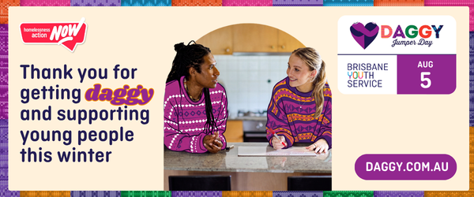
Together, we raised $_____ to support young people facing homelessness across Brisbane.
It was really special to see our school come together wearing wonderful and colourful jumpers, and showing support in such a visible way.
By getting involved, you help young people who are facing homelessness to feel safer and supported when they need it most.
For parents:
Thank you for being part of Daggy Jumper Day 💜
Together, we raised $_____ to support young people facing homelessness across Brisbane.
We really appreciate your support – whether that was through donations, conversations, or helping our students get involved.
It all adds up to helping Brisbane Youth Service support young people when they need it most.

