
PRESENTATION TEMPLATE for team meetings, assemblies, classrooms, and gatherings to introduce Daggy Jumper Day and your plans during Homelessness Week (Canva sign-in required).
Instructions:
- Click on the Presentation Template Canva link.
- Log into Canva if prompted.
- Review the presentation. Feel free to add or update slides as needed.
- Click on the ‘Present’ button when you are ready to share with your group.
Editable presentation with pre-made slides and template slides. | 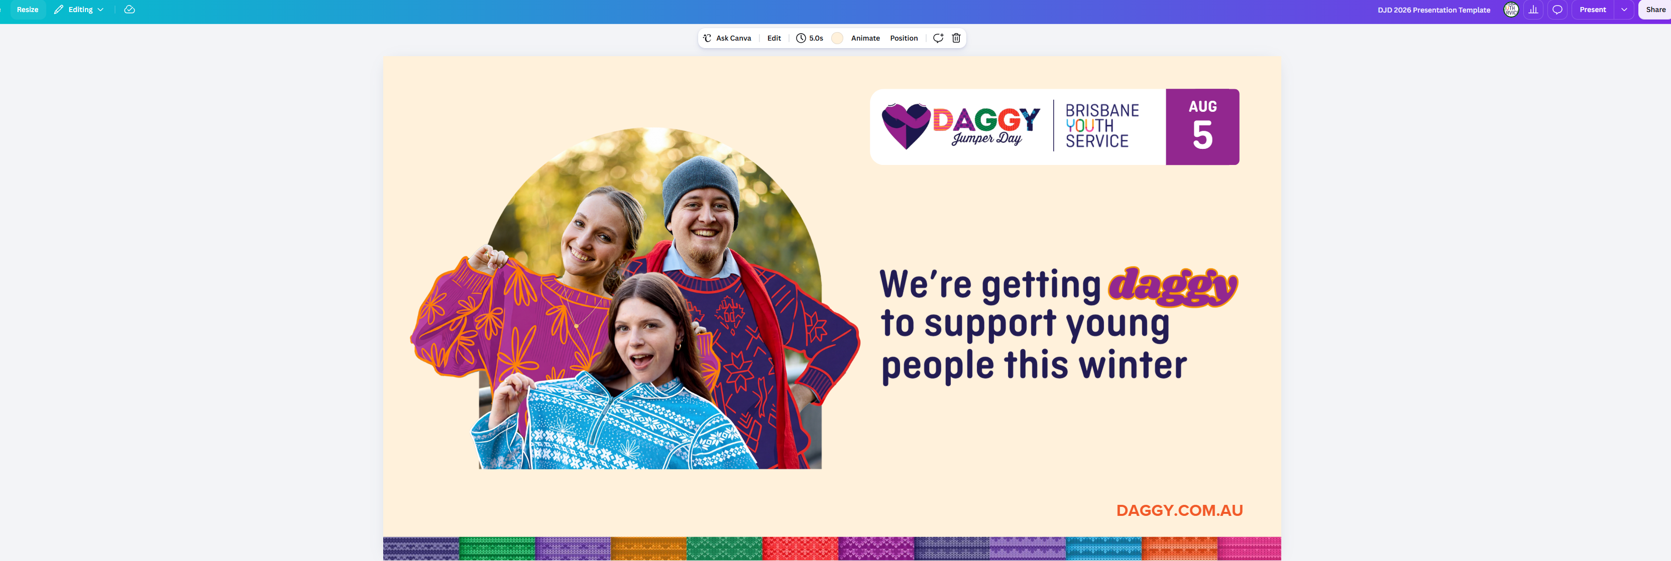  https://canva.link/nn5yo1i0ndstb2n

