Teams announcement template (Update for meetings or internal channels (e.g. Teams, Slack))
Hey team,
I’m excited to announce that it’s time to get daggy for Brisbane Youth Service this Homelessness Week (3-9 August)! We’re taking part in Daggy Jumper Day to show up for young people in Brisbane who are experiencing or at risk of homelessness this winter.
I invite you to don your most colourful, loudest and daggiest jumpers (think Kath and Kim) on the Wednesday 5 August.
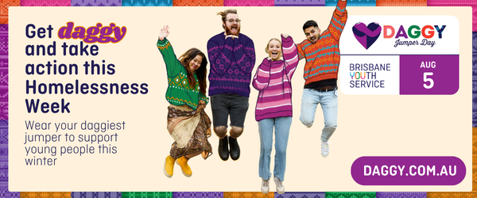
The jumper you wear is entirely up to you. It could be an op shop find, a vintage favourite, a handmade creation, a family hand-me-down, a sentimental piece, or simply the daggiest thing in your wardrobe.
Daggy Jumper Day is an easy and visible way for us to show our support, spark meaningful conversations, and take action for young people across Brisbane.
We’ll also be [Insert Fundraising or Engagement idea here. See Page 6 in the Daggy Jumper Day Workplace and Community Toolkit for ideas.]
Your support in this means Brisbane Youth Service can continue to offer safety, stability, and hope for young people when they need it most.
So, let’s make this winter a little warmer and show that hope is always in style!
Kindest,
[Insert name]

Team email template
Hi team,
I'm excited to announce that we're getting daggy for Brisbane Youth Service this Homelessness Week (3-9 August)! On Wednesday 5 August, we'll be taking part in Daggy Jumper Day to support young people in Brisbane who are experiencing or at risk of homelessness this winter.
We invite you to wear your most colourful, loud, and daggy jumper (Think Kath and Kim). Whether it's an op-shop treasure, a vintage favourite, a handmade creation, a family hand-me-down, a sentimental piece, or simply the daggiest thing in your wardrobe, every jumper helps raise awareness for an important cause.
This is a chance for us to come together, spark meaningful conversations, and take action to support young people experiencing homelessness in our community.
We'll also be [Insert Fundraising or Engagement idea here] to help raise funds and support throughout the day.
By getting involved, you'll help Brisbane Youth Service continue to provide safety, stability, and hope for young people when they need it most.
So, let's make this winter a little warmer and show that hope is always in style.
For more information and ready-to-use resources, visit daggy.com.au.
Thanks for your support, and we can't wait to see your daggy jumpers!
Kind regards,
[Insert name]

Newsletter template

Get daggy this Homelessness Week (3-9 August)!

This Wednesday 5 August, we're taking part in Brisbane Youth Service's Daggy Jumper Day to support young people in Brisbane who are experiencing or at risk of homelessness this winter.

We're inviting everyone to wear their most colourful, loud, and daggy jumper. Whether it's an op-shop find, a vintage favourite, a handmade creation, or a treasured hand-me-down, every jumper helps raise awareness and start conversations about youth homelessness.

We'll also be [Insert Fundraising or Engagement idea here] to help make an even bigger impact.

By taking part, you help Brisbane Youth Service provide safety, stability, and hope for young people when they need it most.

So, don on your daggiest jumper and help make this winter a little warmer because hope is always in style.

[Amend details below as needed to reflect your Daggy Jumper Day plans]
📅 Date: Wednesday 5 August or anytime during Homelessness Week.
🧥 What to wear: Your daggiest jumper
💛 Why: To support young people experiencing or at risk of homelessness
💜 How: [Insert Fundraising or Engagement idea details here]

Thank you message

Thank you everyone for getting behind Daggy Jumper Day 💜

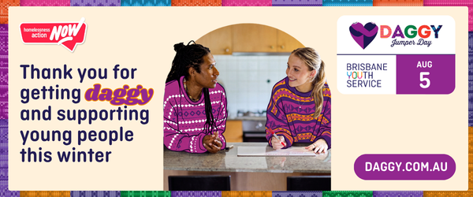

Together, we raised $_____ to support young people who are experiencing or at risk of homelessness in Brisbane.

It’s been great to see everyone get involved – bringing a bit of fun while also taking meaningful action this Homelessness Week.

It all adds up to helping Brisbane Youth Service support young people when they need it most.

